Biology Translation
Translation is the process where single stranded mRNA is “read” one codon at a time (3 nucleotides), to make a protein. A codon is the same thing as an amino acid, the building blocks of proteins. Translation takes place at the ribosome a large multi-subunit protein complex designed to hold the mRNA, identify the codon, and allow for the corresponding amnio acid to attach to the growing peptide chain. This ribosome subunit, the tRNA or transfer RNA is itself a sequence of amino acids where one end has the complementary amino acid for that particular codon in the mRNA, and another amnio acid on the other end.
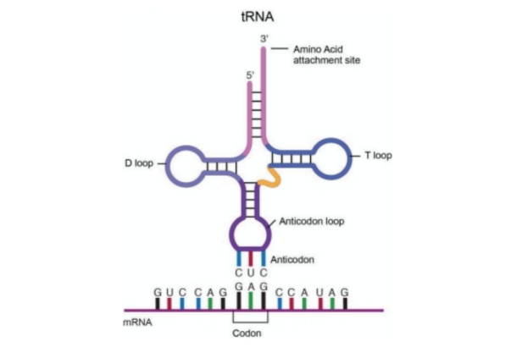
https://www.thoughtco.com/rna-373565/

Thus, you can see that this is a continuous process. One tRNA that has the complement nucleotides of the mRNA, binds the mRNA, and has the corresponding amino acid on the other end. As one tRNA comes in from the left , and moves across to the right, after it binds to the previous tRNA right before it, the amnio acids joins by theoir peptide bind, and the tRNA exits

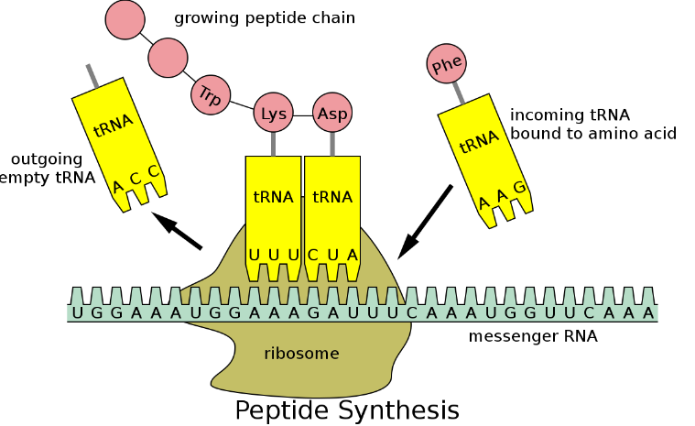

https://en.wikipedia.org/wiki/Transfer_RNA/

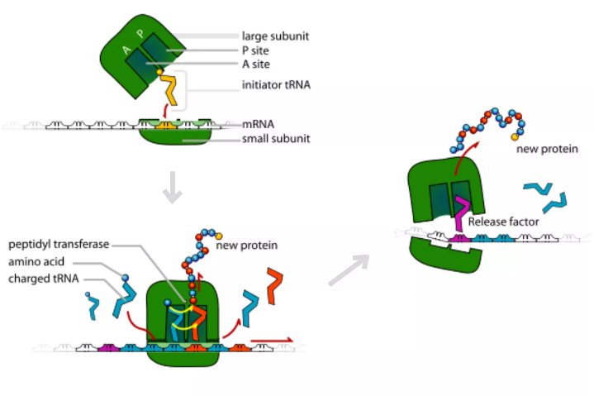

https://www.thoughtco.com/protein-synthesis-translation-373400/

